# COMP122 - Assessment 4

## Information

|  |  |
| --- | --- |
| **Name:** | Oliver Legg |
| **Email:** | [O.Legg@student.liverpool.ac.uk](mailto:O.Legg@student.liverpool.ac.uk) |
| **Student ID:** | 201244658 |

## Contents:

1. Requirements
2. Analysis and Design
3. Class Diagram
4. Pseudocode
5. Testing
6. Testing Evidence

## Requirements

### Part 1

For part 1 requirements, I must extend java’s JFrame swing class to create window like shown below.

### https://i.gyazo.com/015cf70598dac5849bf5789634e86ec1.png

I must sell 9 products on this window and implement stock so that when the user purchases an item, the stock decreases (obviously not below 0). If I try to buy anything below 0 a window should pop up telling me that I can’t purchase the item.

Afterwards I must implement a vendor information button that opens a vendor information frame. In this frame it will display the total sales I have made. It will have another button which resets the stock too and sets the total sales back to 0.

Closing the main window should exit the program. However, closing the “Vendor Information” window should not close the application, nor should closing the other “no stock left” message windows.

### Part 2

In this assignment I am required to call the application program “Doors.java” and use an abstract class for subclasses to be extended from. The way my program will start is to take 1 parameter N (integer). Which will represent the number of doors. This must be in a range from 1 to 1000000. I should also error handle input here. This will be done by giving the user a helpful tip if they enter something incorrectly - like a string. After a subsequently invalid input, the program will exit. In the program I will output the doors they open and close. Obviously, before they perform they will have to have all their doors closed (set to 0).

## Analysis and Design

### Part 1

In part 1 my goal is to develop a GUI. Specifically, I will be building the basic GUI of a Vending Machine. Obviously, there’s no actual vending machine that will be used here, but I will be developing a frame that shows nine products, each having a stock level and a price.

The idea is that when I press a button, the corresponding item will have its stock decrease and the total sales that would increase by the amount of the item that has been sold.

The GUI will also include another button that will open a “Vendor’s Window”. This window will show the total amount of sales (since the last time this button was pressed). This window will also have a button that will reset the stock levels to their start values, and will reset the total sales to 0

From this information I have gathered, I know I am going to use java swing to create my GUI. Knowing that I will be creating 2 frames:

* Main panel
* Vendor Information

I will create 2 classes that extend JFrame and implements ActionListener. This is because it will make it more organised separating the two frames. The action listener is there to create action when you press a button.

As there is a lot of information to be held about the candy, I intend to create a ‘Candy’ class. On instantiation, I will pass the name of the candy the price of the candy and the initial stock of it.

When I am programming my frames, I must make the labels public to other files so that the other files can change the text. This is because I will interact with something on frame 1 which will consequent frame 2 to change its data too. Therefore, both classes will have to ‘use’ each other.

When someone is buying a product, my vending machine shouldn’t allow the user to buy an item if it out of stock. If they try to do this, they will get an information message that they can’t buy the item because it is out of stock.

### Image result for door with long corridorPart 2

Now for this section, I will be considering a situation where there are people who like to open and shut doors in possibly strange fashions. There will be 3 types of people who open and doors in different a consistent fashion. The 3 people are:

* Ginny
* Petra
* Sven

Since these people will have similar properties, I will create an abstract super class which shares the similar traits. For example, Ginny, Petra and Sven would have the same attributes (with different data obviously) such as name, doors, number of doors, doors list etc. Not only this but they would share methods too – especially if attributes are private or even protected. These could be accessors like getName() or getList(). The method that runs the fashion that they open/close doors would be an abstract method that they could all use. I intend the super class to be called players which would be an abstract class. I intend to structure my program so that you instantiate in the subclasses and to check input error in a file called Doors.java. The input I will validate should be strict because my program will create an error if the user inputs a string when they meant to input an integer. I must also create a range of what numbers the user can enter. For example, their input should be 1-1000000. Any higher than that, it might create a memory leak.

When each person begins, I should have them start with a configuration of all closed doors. Then after performing the full procedure for that person, report on the number of doors that are open.

#### Ginny

Ginny toggles the door based on the number in the greatest common divisor (gcd(N,*k*)). The numbers that are inserted are the number of doors – 1 (n). The second parameter is the index of the doors. So, if there were 10 doors, the first door you would change would be gcd(11,0) which is 11. If the gcd(11,0) == 1, (which it does), then the doors would flip on the second parameters doors index e.g. my previous example wouldn’t change door 0 because it doesn’t equal to 1. On gcd(11,1) this would equal to 1. So the doors so far would be ‘01’.

#### Petra

Petra toggles doors based on it’s index too – specifically – if it’s a prime number. Petra doesn’t consider 1 to be a prime number. p that is less than or equal to N, Petra toggles all doors that are prime. E.g

N = 9

0 and 1 are not prime therefore the first door Petra would flip would be 1.

0000000000  
0010000000

Afterwards, I would flip 3.

0011000000

Etc

#### Sven

Sven flips pairs of perfect square numbers. A perfect square number is something like (1,4,9). Because 1x1 = 1, 2x2 = 4, 3x3 = 9. However, Sven would get a pair of perfect square numbers like (1,4). The first number of the parameters is the distance Sven would walk in. After that the number would be 1+4. Therefore, the index of 1 and 5 would change. For example,

N = 1
Pair = (1,4)
0 1 2 3 4 5 6 //indexes
0 0 0 0 0 0 0 //before
0 1 0 0 0 1 0 //after 

This would then repeat for all the pairs it can make. Obviously, there can’t be a pair of (3, 5) because this would go to the index of 8 and that’s out of range.

## Class diagram

### Part 1

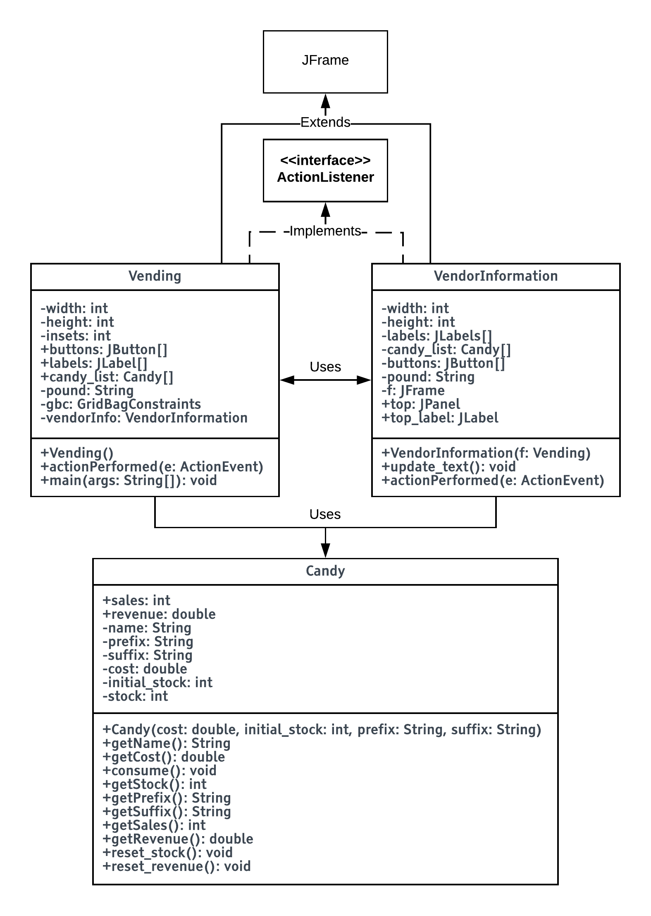

### Part 2

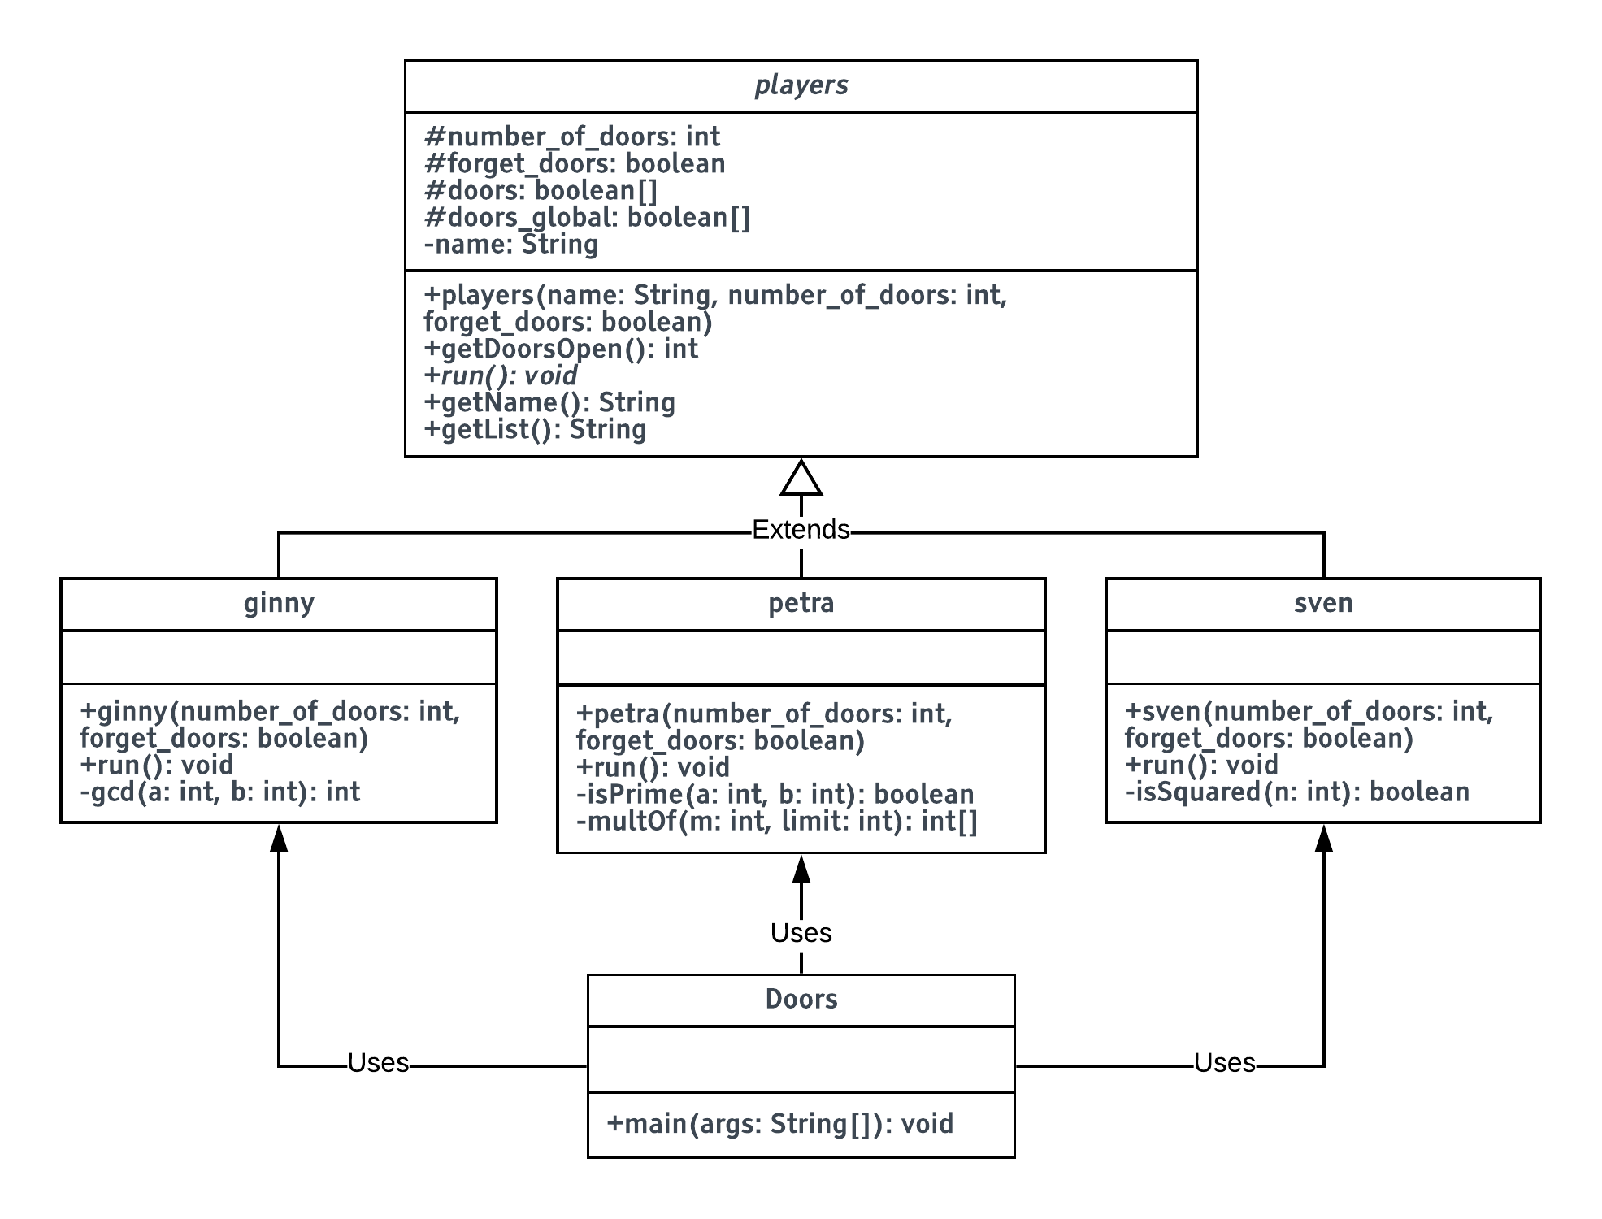

## Pseudocode

### Part 1

Vending()

setFrameName("Twisty JigglyBomb surprises")

vendorInfo.SETVISIBLE(**false**)

candy_list[0] := Candy("Chocolate", "Jigglypuffs", 1.30, 4)

candy_list[1] := Candy("Caramel", "Jigglypuffs", 1.30, 4)

candy_list[2] := Candy("French Vanilla", "Jigglypuffs", 1.30, 4)

candy_list[3] := Candy("Chocolate", "Bombs", 1, 4)

candy_list[4] := Candy("Caramel", "Bombs", 1, 4)

candy_list[5] := Candy("French Vanilla", "Bombs", 1, 4)

candy_list[6] := Candy("Chocolate", "Twists", 0.80, 4)

candy_list[7] := Candy("Caramel", "Twists", 0.80, 4)

candy_list[8] := Candy("French Vanilla", "Twists", 0.80, 4)

x := 0

y := 0

-*-* THIS LOOP PLACES THE BUTTONS IN A 3x3 LAYOUT

FOR i := 0 loop till i < buttons.length by i++ each step

text := candy_list[i].getName()

stock := candy_list[i].getStock() + " left"

cost := "£"+candy_list[i].getCost()

buttons[i] := JButton(text + cost)

buttons[i].setPreferredSize(Dimension(257, 30)) *-- width, height*

labels[i] := JLabel(stock)

IF (i % 3 == 0)

x++

y := 0

gridx := x

y++

gridy := y

buttons[i].addActionListener(**this**)

y++

gridy := y

b := JButton("Vendor Information")

b.setPreferredSize(Dimension(257, 30))

b.addActionListener(**this**)

setBounds(0, 0, width, height)

setVisible(**true**)

setLocation(0, 70)

function actionPerformed(ActionEvent e)

FOR i := 0 loop till i < candy_list.length by i++ each step

IF (e.getActionCommand().equals(button[i].name))

IF (candy_list[i].getStock() > 0)

candy_list[i].consume()

labels[i].setText(candy_list[i].getStock() + " left")

vendorInfo.update_text()

ELSE

JOptionPane.showMessageDialog(NIL, "Oops. there are none left!")

IF (e.getActionCommand().equals("Vendor Information"))

vendorInfo.update_text()

vendorInfo.repaint()

vendorInfo.pack()

vendorInfo.setVisible(**true**)

function main(String[] args)

Vending()

VendorInformation(Vending f)

setFrameName("Vendor Information")

button.addActionListener(SELF)

top_label := JLabel("Total Sales: " + "£" + Candy.getRevenue())

setBounds(0, 0, width, height)

function update_text()

top_label.setText("Total Sales: " + pound + "£" + Candy.getRevenue())

function actionPerformed(ActionEvent e)

IF (e.getActionCommand().equals("Reset stock"))

Candy.reset_revenue()

FOR i := 0 loop till i < candy_list.length by i++ each step

candy_list[i].reset_stock()

labels[i].setText(candy_list[i].getStock() + " left")

labels[i].setForeground(Color.BLACK)

String temp := "£" + Candy.getRevenue()

top_label.setText("Total Sales: " + pound + temp)

Candy(prefix, suffix, cost, initial_stock)

prefix := prefix

suffix := suffix

name := prefix + " " + suffix

cost := cost

stock := initial_stock

initial_stock := initial_stock

function getName()

RETURN name

function getCost()

RETURN cost

function getStock()

RETURN stock

function getPrefix()

RETURN prefix

function consume()

IF (stock > 0)

stock--

sales++

revenue := revenue + cost

function getSales()

RETURN sales

function getRevenue()

RETURN revenue

function reset_stock()

stock := initial_stock

function reset_revenue()

revenue := 0

### Part 2

function main(String[] args)

num_of_doors := 0

testing := **true**

IF (args.length <= 0)

OUTPUT "\nOops, not enough arguments!"

OUTPUT "Usage: java Doors N (String)"

EXIT()

TRY

num_of_doors := args[0]

EXCEPT (VARTYPE)

OUTPUT "\nOops, enter an integer!"

OUTPUT "Usage: java Doors N (String)"

EXIT()

IF (num_of_doors < 1 OR num_of_doors > 1000000)

OUTPUT "\nN must be between 1 and 1000000 !"

OUTPUT "Usage: java Doors N (String)"

EXIT()

IF (args.length > 2)

OUTPUT "\nOops, too many arguments!"

OUTPUT "Usage: java Doors N (String)"

EXIT()

players[] p := players[0..2]

p[0] := ginny(num_of_doors)

p[1] := petra(num_of_doors)

p[2] := sven(num_of_doors)

FOR i := 0 loop till i < p.length by i++ each step

OUTPUT p[i].getName()

p[i].run()

IF (testing)

OUTPUT p[i].getList()

OUTPUT p[i].getDoorsOpen() + " doors open"

players(String name, number_of_doors)

name := name

number_of_doors := number_of_doors

doors := [number_of_doors-1]

FOR i := 0 loop till i < doors.length by i++ each step

doors[i] := **false**

function getDoorsOpen()

count := 0

FOR i := 0 loop till i < number_of_doors by i++ each step

IF (doors[i])

count++

RETURN count

function ABSTRACT run()

function getName()

RETURN name

function getList()

String output := ""

FOR i := 0 loop till i < number_of_doors by i++ each step

IF (doors[i])

output := output + "1"

ELSE

output := output + "0"

RETURN output

ginny(number_of_doors):

SUPER("Ginny", number_of_doors + 1)

function run()

gcdlist := []

FOR i := 0 loop till i < number_of_doors by i++ each step

gcdlist[i] := gcd(number_of_doors - 1, i)

FOR i := 0 loop till i < number_of_doors by i++ each step

IF (number_of_doors == 2)

IF (doors[i])

doors[i] := **false**

ELSE

doors[i] := **true**

IF (gcdlist[i] == 1)

IF (doors[i])

doors[i] := **false**

ELSE

doors[i] := **true**

function gcd(a, b)

IF (a == 0 OR b == 0)

RETURN 0

ans := 1

FOR i := 1 loop till (i <= a AND i <= b) by ++i each step

IF (a % i == 0 AND b % i == 0)

ans := i

RETURN ans

petra(number_of_doors):

SUPER("Petra", number_of_doors + 1)

function run()

[] flippers

FOR i := 0 loop till i < number_of_doors by i++ each step

IF (i < 2)

doors[i] := **false**

ELSE

IF (isPrime(i))

flippers := multOf(i, (number_of_doors - 1))

FOR v := 0 loop till v < flippers.LENGTH by v++ each step

IF (doors[flippers[v]])

doors[flippers[v]] := **false**

ELSE

doors[flippers[v]] := **true**

function isPrime(n)

IF (n == 2 OR n == 3)

RETURN **true**

ELSE

FOR i := 2 loop till i <= ROUNDUP(sqrt(n)) by i++ each step

IF ((n % i) == 0)

RETURN **false**

RETURN **true**

function multOf(m, limit)

newLimit := Math.ceil(limit / m)

[] list := [0..newLimit + 1-1]

FOR i := 0 loop till i <= (newLimit) by i++ each step

list[i] := i * m

RETURN list

sven(number_of_doors):

SUPER("Sven", number_of_doors + 1)

function run()

FOR i := 1 loop till i < number_of_doors by i++ each step

FOR v := i + 1 loop till v < number_of_doors by v++ each step

IF (isSquared(i) AND isSquared(v))

IF ((i + v) < number_of_doors)

IF (doors[i])

doors[i] := **false**

ELSE

doors[i] := **true**

IF (doors[(i + v)])

doors[(i + v)] := **false**

ELSE

doors[(i + v)] := **true**

function isSquared(n)

n2 := Math.sqrt(n)

IF (n2 == n2)

RETURN **true**

ELSE

RETURN **false**

## Testing

### Part 1 – To evidence

|  |  |  |  |  |
| --- | --- | --- | --- | --- |
| Test number | Description | Expected Results | Actual results | Remedial Action |
| 1 | Frame | The frame it’s self appears and works in a readable layout. | Yes |  |
| 2 | Buttons press | They’re interactable | Yes |  |
| 3 | Button press 2 | Stock corresponding to product decreases when pressing buttons | Yes |  |
| 4 | Stock validation | Stock should remain at 0 when trying to purchase another item | Yes |  |
| 5 | InfoBox | When trying to purchase below 0, you should get an info box telling you that you can’t purchase below 0 | Yes |  |
| 6 | Vendor Information Button | The vendor information frame must appear when you press the button | Yes |  |
| 7 | Total sales | Correct number of total sales shows and updates correctly. Purchasing 1 Chocolate bomb. Should (£1.00) | Yes |  |
| 8 | Reset stock button | Reset stock button should stock all of the products back up to it’s original value and set the total sales back to £0.00 | Yes |  |

### Part 2 – To Evidence

|  |  |  |  |  |
| --- | --- | --- | --- | --- |
| Test number | Description | Expected Results | Actual results | Remedial Action |
| 1 | Input validation 1 | Entering no parameters when starting the program should produce a helpful message for the user and exit the program | Yes |  |
| 2 | Input validation 2 | Entering a number below 1 or above 1000000 should produce a helpful message for the user and exit the program | Yes |  |
| 3 | Input validation 3 | Entering a string should return a helpful message and exit the program | Yes |  |
| 4 | Input Validation 4 | Entering an extra parameter should create a helpful message and exit the program | Yes |  |
| 5 | Sample output 1 | Input 9 – see evidence for expected result (click the link on the subheading) | Yes |  |
| 6 | Sample output 2 | Input 30 | Yes |  |
| 7 | Sample output 3 | Input 23 | Yes |  |
| 8 | Sample output 4 | Input 1 | Yes |  |
| 9 | Sample output 5 | Input 25000 | Yes |  |
| 10 | Sample output 6 | Input 67325 | Yes |  |

## Testing Evidence

(Test number correspond with tests on previous section)

### Part 1 – To tests

|  |  |
| --- | --- |
| Test number | Screenshot Evidence |
| 1 | https://i.gyazo.com/0294488a1225bd17f4c033a6723de57c.png |
| 2 |  |
| 3 | https://i.gyazo.com/ffca49551001fd719cfe120d5c58317f.pnghttps://i.gyazo.com/c1bb5f7d82518e163d88de7d790d0501.png |
| 4 | https://i.gyazo.com/fd221a022f931224c8c698f4f2950c7d.png |
| 5 | https://i.gyazo.com/e93f1036566bd4873cd90452ac0e526b.png |
| 6 | https://i.gyazo.com/fef3a5d841f9e092537ec418e80c2357.png |
| 7 | https://i.gyazo.com/6b37bd6440b90769b091e92d70836c9b.png |
| 8 | https://i.gyazo.com/771850f1b8b9777f676c3a8ad2284fb6.pnghttps://i.gyazo.com/51d245f720cb48dbb52177110ca76883.png |

### Part 2 – To tests

|  |  |
| --- | --- |
| Test no | Screenshot Evidence |
| 1 | https://i.gyazo.com/6c2f7a36e567ba37401dead1dc88ec3e.png |
| 2 | https://i.gyazo.com/05438cb082e6b6b8fe24552417c60f01.png |
| 3 | https://i.gyazo.com/11e4f2a746d1385aba86add7829a9e70.png |
| 4 | https://i.gyazo.com/1d6b49384ece02eb67c02cebfda4593c.png This appears like this because of the extra question which allows another parameter. However, it doesn’t allow |
| 5 | https://i.gyazo.com/45431383130bba1a13ebf259441ed5ab.pnghttps://i.gyazo.com/a5b76d7690ecbf6a63dc2c6c6bd4e5b7.png |
| 6 | https://i.gyazo.com/71052d92a4ee073d2fdc1bc67d63b318.pnghttps://i.gyazo.com/85162369b742ff5b018d227ea61c0e2f.png |
| 7 | https://gyazo.com/43b997f60951d209e4f0096e5f42e64a.png https://i.gyazo.com/c93d6d10b8ad2478fbdd0ce76b8e2abf.png |
| 8 | https://i.gyazo.com/1fc83b52944d3e4bdaac7f35eed4a398.png https://i.gyazo.com/806f8df7072892f7c09f37b59dbe300b.png |
| 9 | https://i.gyazo.com/812747bee38e43a4ccdd49b23c43466b.png https://i.gyazo.com/0adf1599145fad90d0ad2bbe57bcf428.png |
| 10 | https://i.gyazo.com/9c590879e9912f77858682c6aecedf81.pnghttps://i.gyazo.com/c87c0ac335c9329b25a53bee935bd792.png |